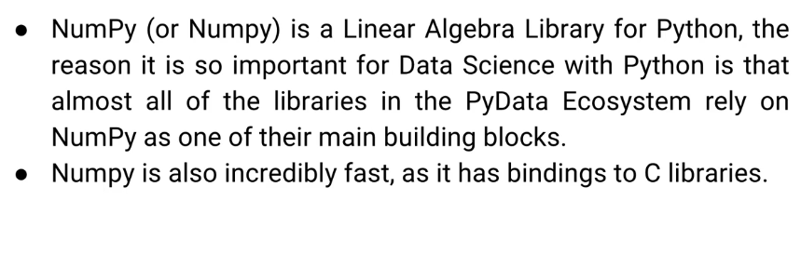

* conda install numpy with Anaconda distribution (recommended)
* pip install numpy if you don’t have the Anaconda distribution

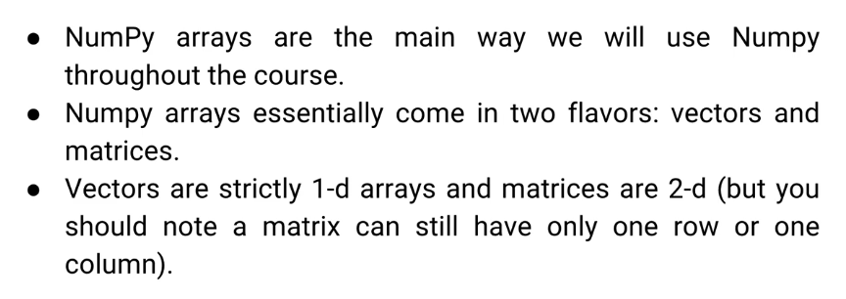

* clicking tab after a fullstop can show the available methods.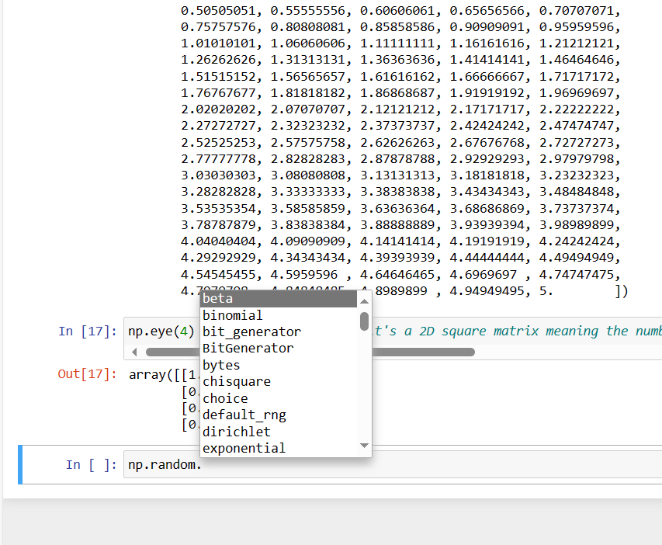
* SHIFT + tab provides intellisense

**Pandas** 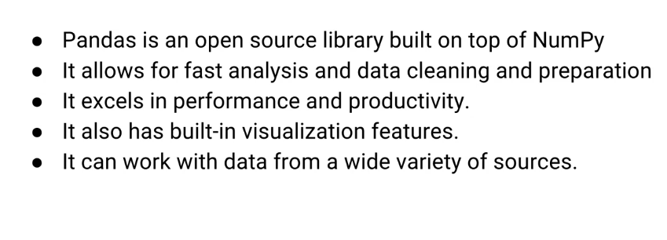

* conda install pandas
* pip install pandas

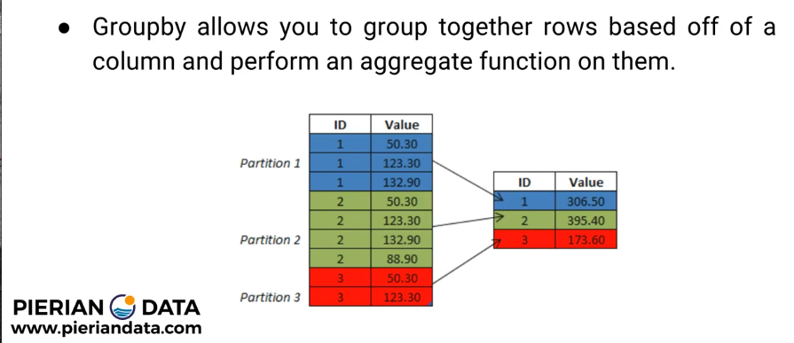

To read from csv, excel, html and sql you’ll need these libraries

* conda install sqlalchemy
* conda install lxml
* conda install html5lib
* conda install BeautifulSoup4

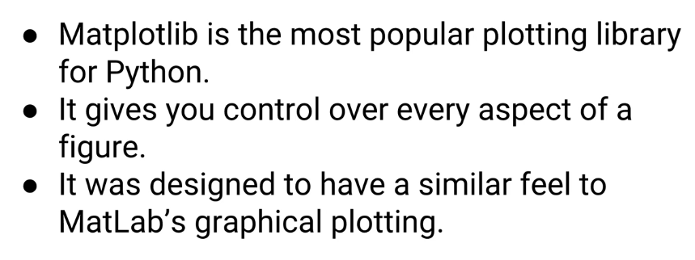

* conda install matplotlib
* pip install matplotlib



* pip install seaborn
* conda install seaborn

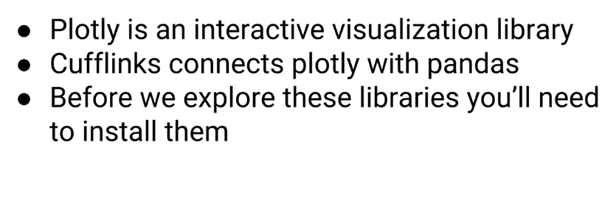

* conda install plotly
* conda install cufflinks

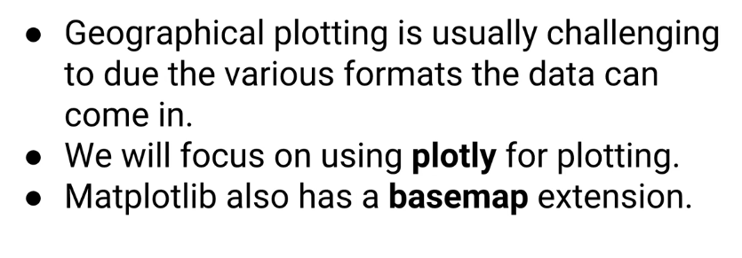

* pip install pandas-datareader allows you to easily retrieve stock information

